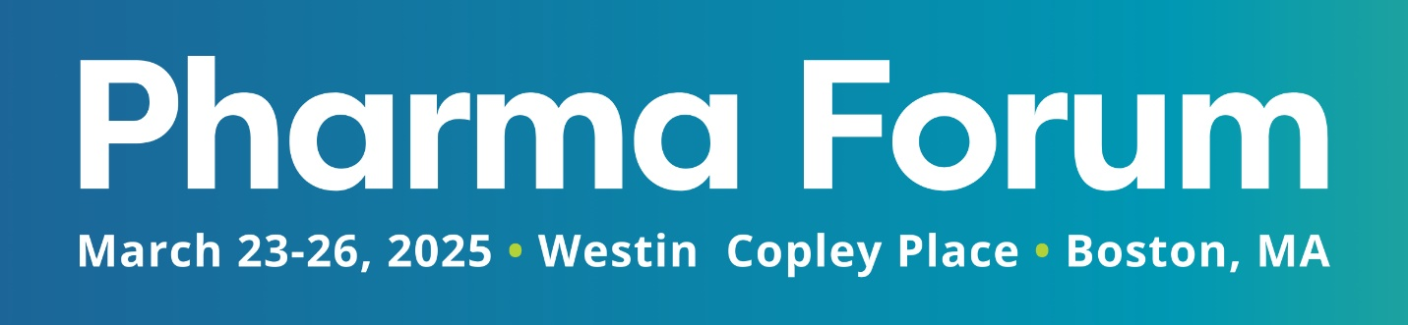

Dear [Manager’s Name],

I am writing to request your approval to attend the 21st Annual [Pharma Forum](https://informaconnect.com/pharma-forum/), taking place March 23-26, 2025 in Boston, MA. This conference unites a diverse range of professionals involved in the planning, organization, and execution of meetings and events for bio/pharma, healthcare, and life sciences companies, addressing the unique challenges and compliance implications faced within our industry. After conducting research, I believe this event would benefit my professional development and our company's continued success.

**Speakers**

Pharma Forum includes a lineup of distinguished [speakers](https://informaconnect.com/pharma-forum/speakers) at the forefront of life sciences meetings and events, including perspectives from corporate, third-party, and association planners, as well as hoteliers, experiential marketing/production companies, and technology providers, to name a few; their insights are sure to be invaluable.

**Content**

The education provided at Pharma Forum is industry specific and directly relevant to my position. The comprehensive program [agenda](https://informaconnect.com/pharma-forum/agenda) is designed to provide insights on the latest industry trends, best practices, and peer-to-peer benchmarking and collaboration though cutting-edge discussions, interactive workshops, and customizable program tracks.

**CMP Credits**

By participating in these sessions, I am eligible to earn Certified Meeting Planner (CMP) credits. Each qualifying session is recognized and accredited by the Events Industry Council (EIC) and will contribute to my ongoing certification requirements, ensuring that I remain current with the latest industry standards and practices.

**Certification Programs**

Additionally, Pharma Forum offers two [certification programs](https://informaconnect.com/pharma-forum/hmcc-program/) onsite, the Medical Meeting Professional (MMP) certificate program and the Healthcare Meeting Compliance Certificate (HMCC) program, both hosted by Meeting Professionals International (MPI), an association recognized as a leader in compliance education by the medical meeting industry. There is an additional fee to participate in these, but Pharma Forum offers both at a discounted rate of $200 off.

**Networking**

Beyond the scheduled sessions, the conference offers numerous networking opportunities. I am looking forward to actively engaging with the vast community of industry professionals to forge new business relationships, allowing me to explore partnerships, source vendors, identify new solutions, and gain fresh perspectives to take back to the team.

**Costs**

Pharma Forum offers two registration options for meeting planners. To assist in reducing company costs, I am opting for the [Planner Pass with 8 Appointments](https://informaconnect.com/pharma-forum/purchase/select-package/), which is complimentary, pending I book and attend a minimum of 8 pre-scheduled appointments with sponsors and/or exhibitors onsite. This pass includes:

* Prelude Summits
* 3 Day Conference
* Expo Hall Access
* Daily Breakfast and Lunch
* On & Off-Site Networking Activities
* Access to the ConnectMe App & Online Portal
* Discounted Hotel Rate via Pharma Forum’s Room Block

The primary costs include travel expenses, accommodations, and the add-on certification programs, which I have outlined below:

* Registration Fee: $0
* Airfare/Travel: [INSERT COST]
* Discounted Hotel Rate: $299 x 3 Nights
* [OPTIONAL] MMP Program: $513.99
* [OPTIONAL] HMCC Program: $513.99
* Additional Expenses: [INSERT COSTS]
* **Approximate Total: [CALCULATE TOTAL COST]**

This investment will pay off in enhanced efficiency and productivity, new insights and ideas, and have an overall impact on our bottom line. I will have tangible benefits and key takeaways to implement and share with our organization, as well as a full year of access to the conference’s recorded and PDF presentations.

Thank you for considering my request and I look forward to the opportunity to represent our organization at this esteemed event.

Sincerely,

[Your Name]