SuperReturn International
4th – 7th June 2024 Intercontinental Hotel, Berlin

Furniture Inclusions:
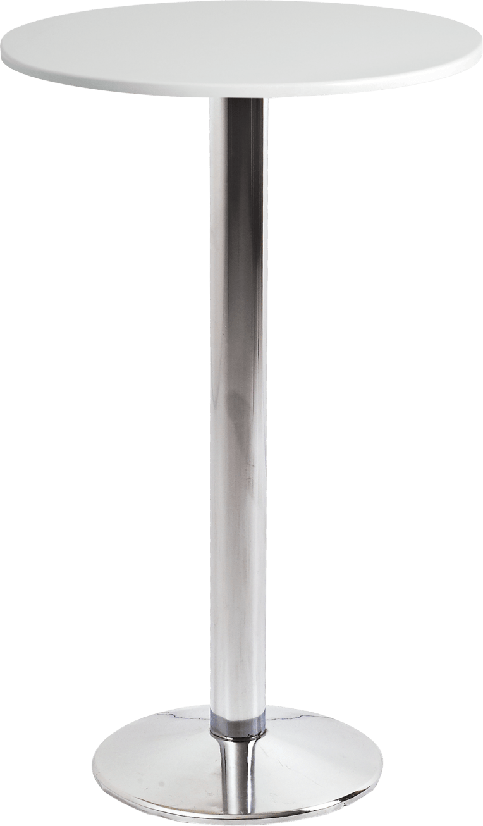 | MILAN CHROME BASE BAR TABLE (WHITE TOP)  Dimensions:  H 1130 x Dia 600 / 700mm- please note dimensions are a guide and may vary
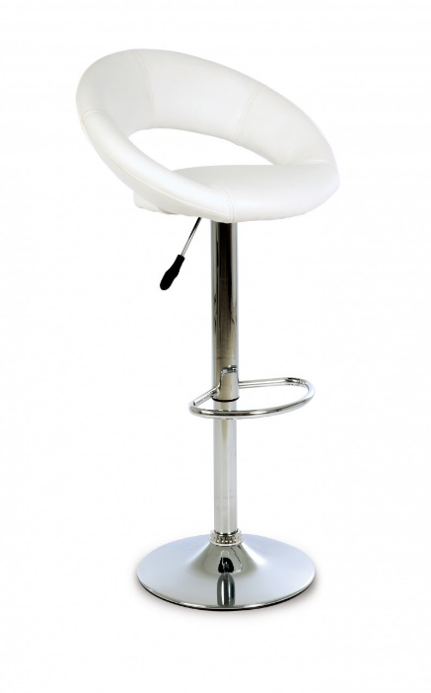 | POLO STOOL SINGLE STEM VINYL SEAT X 2  Dimensions:  H 810-1080 x W 545 x D 485mm, SH 615-815mm- please note dimensions are a guide and may vary

