Shell Scheme at SuperReturn International 2025

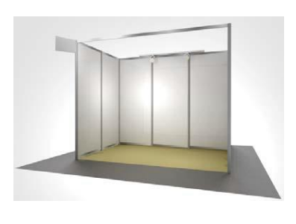
- 1 x 1000kw Double socket
- 2x Spotlights
- Aluminium Framework
- White Foamex Panels
- 1 x poseur table + 2 x stools
- Nameboard with company name and stand
number printed

No materials may be attached to the shell scheme
(nails, hooks etc are forbidden).

