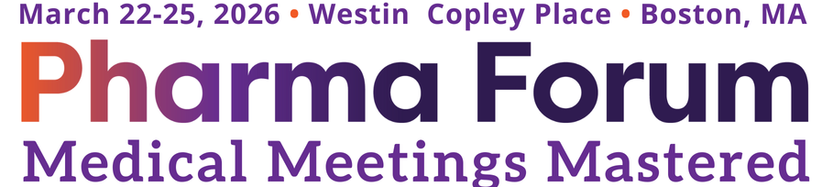

Dear [Manager’s Name],

I am writing to request your approval to attend the 22nd Annual Pharma Forum, taking place March 22-25, 2026 in Boston, MA. This conference unites professionals involved in the planning, organization, and execution of meetings and events for bio/pharma, healthcare, and life sciences companies, addressing the unique challenges around compliance in our industry. After researching educational opportunities in the market, I believe my attendance at this conference will greatly benefit not only my professional development, but also the company’s continued success. With the sessions I’ll participate in and learn from and the connections I’ll meet onsite, this investment will enhance my productivity and inspire new ideas, which will impact our bottom line. I’ll return to the office with tangible takeaways to implement and share along with a full year of access to the conference’s recorded and PDF presentations. Here are additional benefits and the costs:

Benefits:
Pharma Forum offers two registration options for meeting planners. To assist in reducing company costs, I am opting for the Planner Pass with 8 Appointments, which is complimentary, pending I book and attend a minimum of 8 pre-scheduled appointments with sponsors and/or exhibitors onsite. This pass includes:

- Closed Door Facilitated Interactive Summits (specific to type of planner)
- 3 Day Conference (includes 5 tracks + multiple general sessions to choose from – agenda available here)
- Expo Hall Access
- Daily Breakfast, lunch and AM & PM breaks with refreshments
- On & Off-Site Networking Activities, Receptions & Excursions hosted by Pharma Forum and its Sponsors
- Access to the ConnectMe App & Online Portal
- Discounted Hotel Rate via Pharma Forum’s Room Block
- Each session qualifies for Certified Meeting Planner (CMP) credits approved by the Events Industry Council

Costs:
The primary costs include travel expenses, accommodations, and the optional add-on certification programs, which I have outlined below:
- Registration Fee: $0
- Estimated Airfare/Travel: [INSERT COST]
- Discounted Hotel Rate: $299 (plus tax) x 3 Nights
- [OPTIONAL] Medical Meeting Planner Certificate Program: $513.99
- [OPTIONAL] Healthcare Meeting Compliance Certificate Program: $513.99
- Estimated Additional Expenses (any extra meals/snacks): [INSERT COSTS]
- Approximate Total: [CALCULATE TOTAL COST]

Thank you for considering my request and I look forward to the opportunity to represent our organization at this esteemed event.

Sincerely,
[Your Name]

