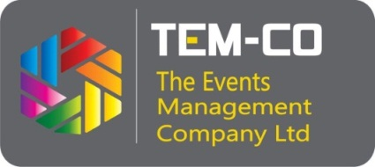
EXTRA FURNITURE/AV/ELECTRICAL ORDER FORM
EAST AFRICA COM NAIROBI, RADISSON BLU HOTEL, 25 – 26 APRIL, 2023
Name of Exhibiting Company & Stand Number (as it should appear on fascia) |  | COMPANY NAME:  STAND NO:
Name of representative:
Email:
Contact Number:
No. | Item as per furniture catalogue provided (see page 2) | Quantity | Unit cost | Total amount to be invoiced
1
2
3
 | TOTAL

NB: ALL Order forms should be received by us on or before 14th April 2023.
NB: Terms of payment: All payment must be received before the start of the exhibition for items to be made available.
All prices are subject to 16% VAT.
Contact details: Anne Mutugi, annem@tem-co.com, +254 722 521498
