USING WHEREBY PACK

IMPORTANT
By registering for this event, you acknowledge recordings, video and photographs are being taken during the event. By you entering this virtual event, you give unqualified consent to: Informa Tech, it’s agents, licensees to record, use and publicise your voice, actions, likeness and appearance, in any manner and media, worldwide in perpetuity. If you wish to avoid being recorded, please do not enter this event.

Speaker Liaison Manager: Brooke Bignold Brooke.Bignold@informa.com

Event Producer: Chris Lycett Christopher.Lycett@Informa.com

WHEREBY SESSION
If you are holding a session using our Whereby platform you will be sent a link to this prior to the event. This will be in enough time for you to be able to go in take a look at the platform and work out what works best for you when hosting the session.

Please DO NOT send this link out to anyone as this may affect the quality and privacy of your session. You must enter this room 10 minutes prior to the beginning of your session.

Whereby privacy statement:

Whereby is GDPR-compliant and do take security very seriously. All conversation data in the room is kept secure with end-to-end encryption, and no conversation data is ever stored by our servers. The specific encryption type used is RFC 3711, which is 128-bit encryption.
For more information please click here: Data Storage and Security
These rooms have a capacity limit, and this will ensure that you can get into your Live Q&A.

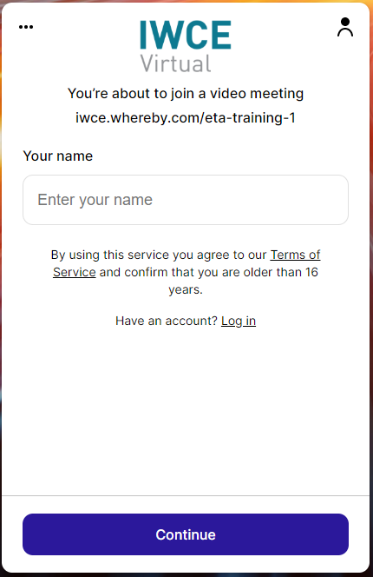
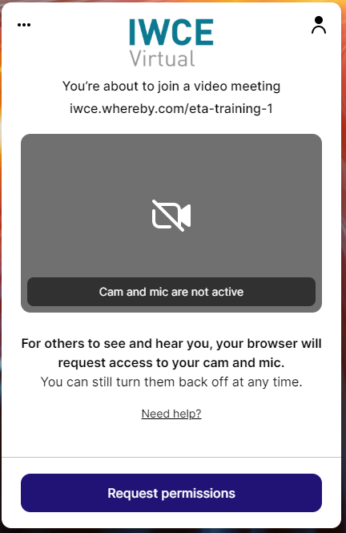
When you first enter the room, you will be greeted with the following screens, where you will need to enter your name, click continue and then request permissions:
1
2

Once you have entered the room you should be able to see a screen similar to the following:
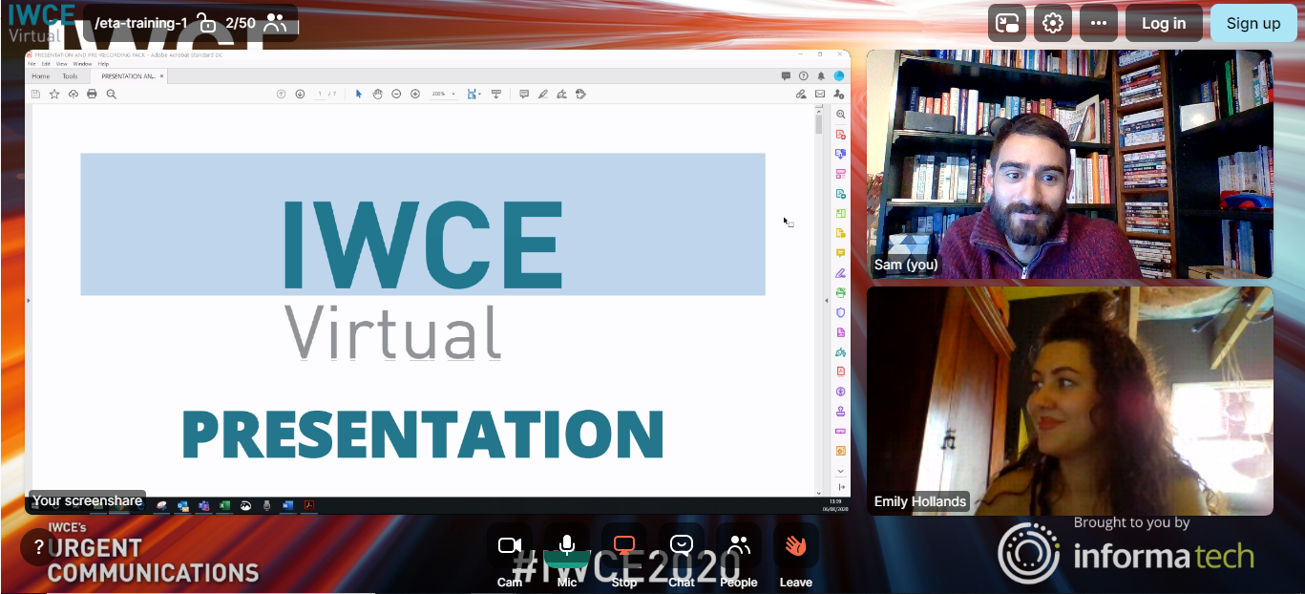
Camera function
Mic
function
Share
function
Chat
function
Attendee list
function
Leave the room

- Lock/Unlock room – Allows you to decide whether anymore attendees can enter the room.
- Camera function – Allows you to turn your video on and off.
- Mic function – Allows you to turn your microphone on and off.
- Share function – Allows you to share your screen, a YouTube link or have a whiteboard during your session.
  - Please upload any videos you wish to present to YouTube as this is currently the best way to ensure the quality of the audio.
- Chat function – Allows you to interact with your attendees by typing questions/responses.
- Attendee list – Allows you to view who is in the room attending the session.
- Leave the room – means you can leave the room without affecting attendees.

Attendees will be able join the session via the Agenda, which they will only be able to see if they have been given permission by Informa beforehand.

There is a chat feature within the ‘Whereby’ room where attendees within the session can ask questions. If you click on the ‘Chat’ button along the bottom, it will open up a chat window to the right of the screen. If you close the chat window, you can also hover your mouse over the ‘Chat’ button and type a message in a small box which will then show your message on top of your video.

We encourage you to keep your camera on in a well-lit room. We would advise that when you are not speaking to please keep your microphone muted and only switch on when you are speaking.

VIDEO & MIC

To indicate you would like to speak, you can also raise your hand during the session or utilise the chat functionality outlined above.

