

PRESENTATION AND PRE-RECORDING PACK

**IMPORTANT**

**By registering for this event, you acknowledge recordings, video and photographs are being taken during the event. By you entering this virtual event, you give unqualified consent to: Informa Tech, it’s agents, licensees to record, use and publicise your voice, actions, likeness and appearance, in any manner and media, worldwide in perpetuity. If you wish to avoid being recorded, please do not enter this event.**

**PRE-RECORDING DEADLINE**

**Pre-recording sessions will need to be completed and submitted no later than Friday 15th October.**

## **PRESENTATION**

**Solo Presentations**

If you are a solo presenter, please record your own session including the use of your presentation slides. Once you have recorded please check the below specifications:

**File type**: MP4

**File size**: No larger than **1GB**

Please WeTransfer (or a suitable alternative) the file over to Brooke Bignold by **Friday 15th October.**

Speaker Liaison Manager: Sam Armstrong [Brooke.Bignold@informa.com](mailto:Brooke.Bignold@informa.com)

Event Producer: Chris Lycett [Christopher.Lycett@Informa.com](mailto:Christopher.Lycett@Informa.com)

**HOW DO I PRE-RECORD MY SESSION?**

**Platforms**

Sessions can be pre-recorded on any of the following:

|  |  |  |
| --- | --- | --- |
| **PowerPoint** | **Microsoft Teams** | **Zoom** |
| **C:\Users\HoemkeM\AppData\Local\Microsoft\Windows\INetCache\Content.MSO\260C322A.tmp** | **C:\Users\hollandse\AppData\Local\Microsoft\Windows\INetCache\Content.MSO\38074499.tmp** | **C:\Users\hollandse\AppData\Local\Microsoft\Windows\INetCache\Content.MSO\5A04AB0F.tmp** |

*Any other suitable platform that renders a **‘.mp4’** file.

To view instructions on pre-recording, please see the options below:

**PowerPoint**

PowerPoint has an in-built recorder to let you record your presentation with narration and/or video.

What you’ll need:

* Microsoft Office (PowerPoint)
* A Microphone (your webcam may have one built in)
* A Webcam (optional)

1. This option can be found on the ‘Slide Show’ tab under ‘Record Slide Show’.

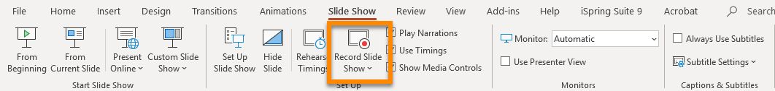

1. Choose Start Recording from Beginning - to record from the beginning of a presentation

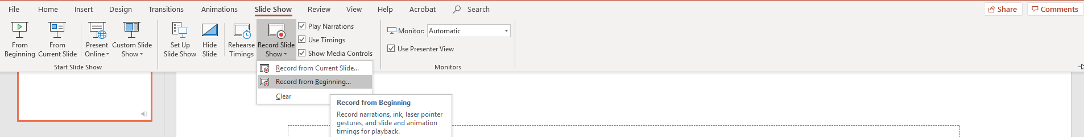

1. 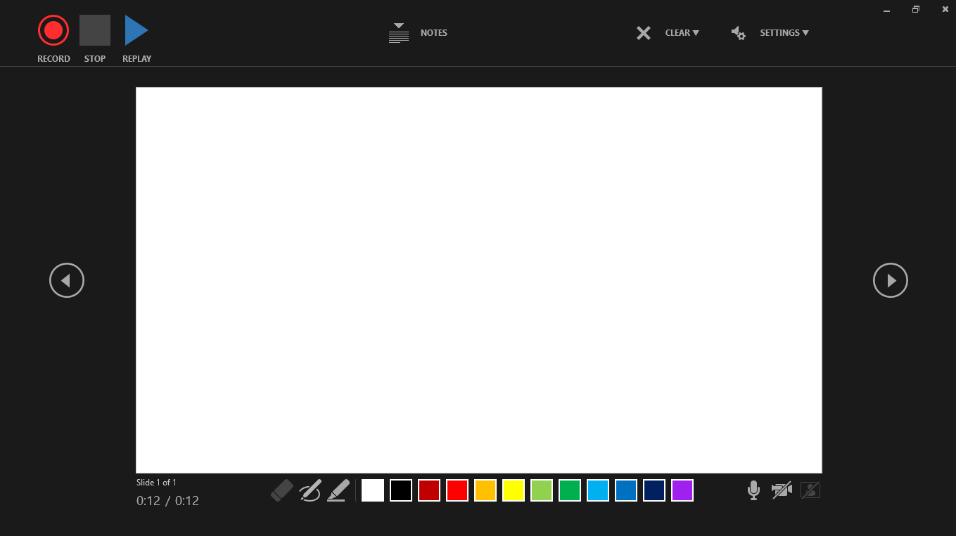The following screen will appear. From here you will need to ensure your audio and video **(1)** are turned on in the bottom right-hand corner, before clicking ‘Record’ **(2)** in the top left-hand corner.

**2**

**1**

1. Start speaking or add markings to your presentation. PowerPoint presentations **cut audio whilst changing slides**, so take a brief pause before moving to the next slide
2. Video on how to record presentations [click here](https://support.microsoft.com/en-us/office/video-record-presentations-2570dff5-f81c-40bc-b404-e04e95ffab33)

**Microsoft Teams Recording**

1. Start or join the meeting.
2. To start recording, go to the meeting controls and select ‘More options’ button > Start recording.
3. To stop recording, go to the meeting controls and select ‘More options’ button > Stop recording   
   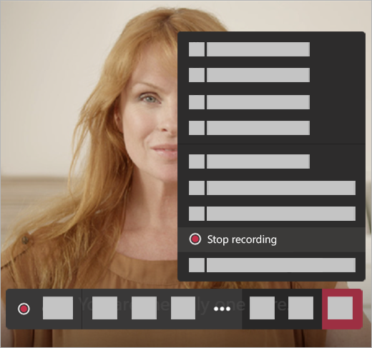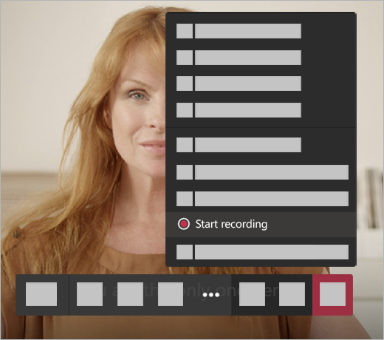  
      
   **a.** The recording is then processed (which could take a while) and saved to Microsoft Stream, and then it's ready to play.

**b.** The person who started the recording receives an email from Microsoft Stream when the recording is available. It also shows up in the meeting chat—or in the channel, if you’re meeting in a channel.

**Zoom Recording**

1. Starting a local recording: The host must record the meeting or grant the ability to record to a participant.
2. Start a Zoom meeting as the host: Click the option to Record.



1. If there is a menu, select ‘Record’ on this Computer: Hosts will see the following recording indicator in the top-left corner while recording is active.

**C:\Users\hollandse\AppData\Local\Microsoft\Windows\INetCache\Content.MSO\8415B647.tmp**

Participants will see the following indicator in the top-left corner while the recording is active.

**C:\Users\hollandse\AppData\Local\Microsoft\Windows\INetCache\Content.MSO\40783EED.tmp**

1. Click Participants to see which participants are currently recording.

**Note:** Dial-in participants will hear a message informing them that the meeting is now being recorded unless disabled by the host.

1. After the meeting has ended, Zoom will convert the recording so you can access the files.
2. Once the conversion process is complete, the folder containing the recording files will open.

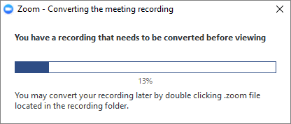 

**Note:** By default, the audio/video file (MP4) will be named Zoom_0.mp4. The audio only file (M4A) is named audio_only.m4a.

**Note:** If the meeting unexpectedly shuts down or if the conversion process is interrupted, the recording files could become corrupted and non-recoverable. Restarting or shutting down your computer, putting the hard disk to sleep, or closing your laptop will interrupt the conversion process.

If the conversion process is not successful after the meeting has ended, you can try to convert the files again by navigating to the recording location and double clicking the recording files.

You can record the meeting in different layouts including active speaker, gallery view, and shared screen.   
 