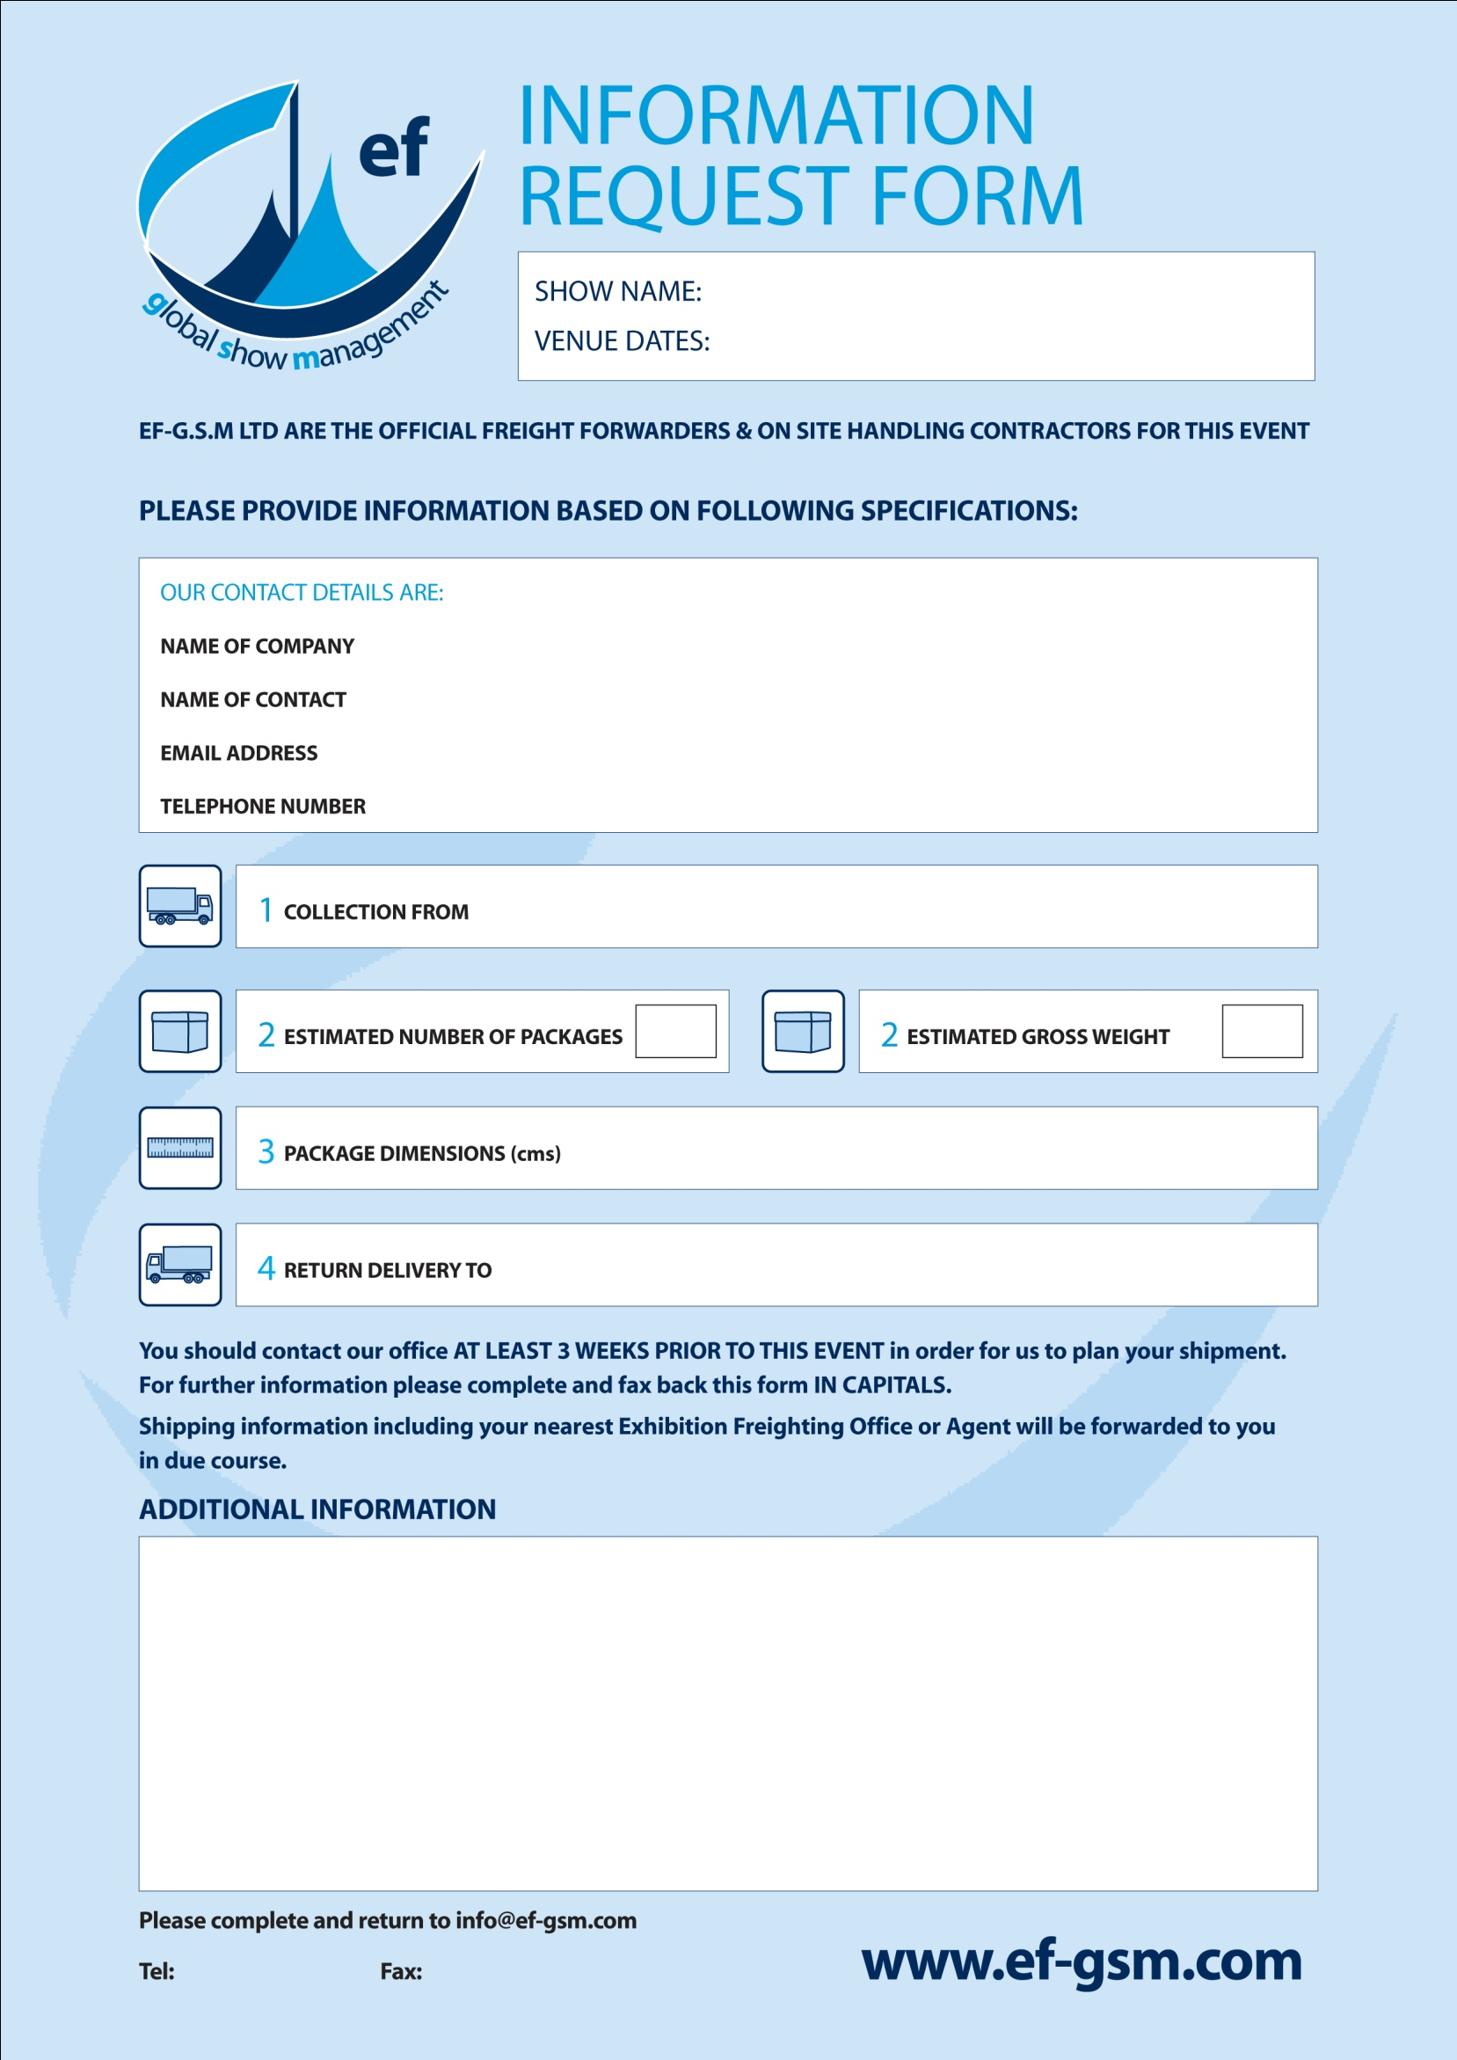

**daniel@ef-gsm.com**

**+441732 885131**

**+441732 886689**

Type

Type

Type

## BROADBAND WORLD FORUM 2021

**12-14 OCTOBER 2021**

Type

Type

Type

Type

Type

Type