Booth ID Sign 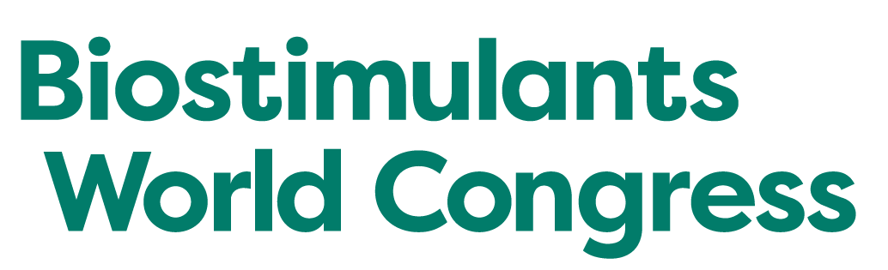
DEADLINE: October 8th 2021

A booth ID sign is included with your booth package. Show management will order your sign for you directly through GES Exposition Services and there will be no charge to you for this sign.

Show management cannot guarantee any sign changes after the due date above.

If you do not submit this form your sign will be ordered based on the company name listed on your event contract.

Dimension: 7" H x 44" W
Lettering: Signs are printed in all capital letters
Placement: Signs are hung over the back of your pipe and drape at a height of 8 feet for exhibitors, and in the top of the structure for shell scheme stands for Bronze/ Silver Sponsors.
Graphics: There are NO graphics included on these signs.

Our Sign should read exactly as follows:
Company Name: ________________________________________________________
Booth Contact: _________________________________________________________
Today’s Date: __________________________________________________________

SAMPLE SIGN FORMAT:
ABC, Inc. Booth #

------------------------------------- 44” --------------------------------------

Please email this form to Isabella Pulley
Isabella.Pulley@informa.com

