BRONZE PACKAGE

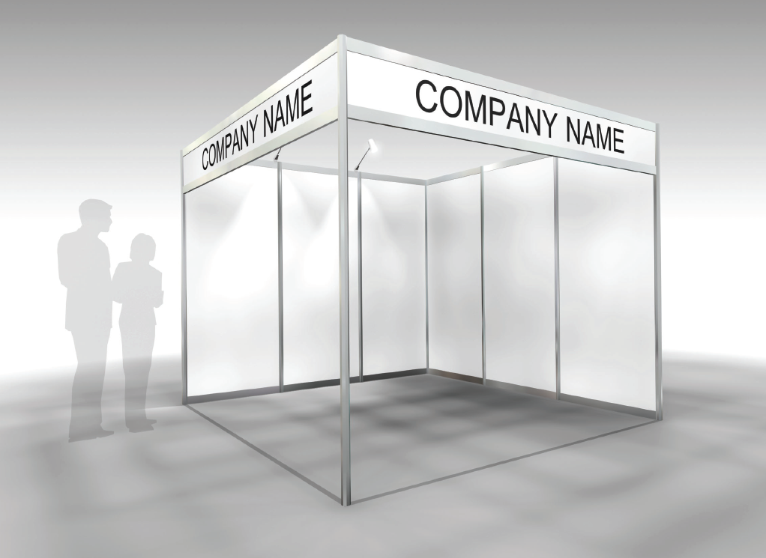

How to order graphics:
https://ordering.ges.com/052602203/Signs

File Name should include:
BIOSWC
Exhibiting Company Name
Bronze, Silver or Gold Booth

Example: BIOSWC_company name_Bronze

GRAPHIC DIMENSIONS
 | INCHES  LENGTH | INCHES  HEIGHT | METERS  LENGTH | METERS  HEIGHT
PANEL A- HEADERS | 116 7/8” | 12” | 2.968625 | 0.3048
PANEL B- BACKWALL | 38 1/8” | 91 3/8” | 0.968375 | 2.320925
PANEL B- SIDEWALL | 38 1/8” | 91 3/8” | 0.968375 | 2.320925

